- What are the two values of the Boolean data type? How do you write them?

Ans: True and false (0 , 1).

- What are the three different types of Boolean operators?

Ans: The three types of boolean are ‘AND’,’OR’ ,’NOT’.

3. Make a list of each Boolean operator’s truth tables (i.e. every possible combination of Boolean
values for the operator and what it evaluate ).

Ans: Truth table for Boolean operators.

AND
A | B | Output
0 | 0 | 0
1 | 1 | 1
1 | 0 | 0
0 | 1 | 0

OR
A | B | Output
0 | 0 | 0
1 | 1 | 1
1 | 0 | 1
0 | 1 | 1

NOT
A | Output
0 | 1
1 | 0

4. What are the values of the following expressions?

Ans: (5>4) and (3 == 5)- False

Not(5>4) - False

(5>4) or (3==5) - True

not ((5>4) or (3 == 5)) - False

(True and True) and (True == False) - False

(not False) or (not True) - True

- What are the six comparison operators?

Ans: six comparison operators.
> (Greater than)
<(less than)
==(Equal to)
!=( Not equal to)
>=( Greater than or equal to)
<= ( Less than or equal to)

6. How do you tell the difference between the equal to and assignment operators?Describe a
condition and when you would use one.

Ans: The equal to operators (==) checks the value of datatype and then return to boolean output.

The assignment operators assign the value for a variable.

Case 1: To check two numbers are equal or not, we will use equal to operators.

If a==b
Print (“The numbers are equal”)

Else:
Print (“The numbers are not equal”)

Case 2: To assign a value to variable we will use the assignment operators.
A =10
B = 20

Print (a+b)

7.Identify the three blocks in this code:

Ans: These are the three block, Highlighted in different colors.

spam = 0

If spam ==10
Print (“eggs”)
if spam > 5:
Print (“bacon”)
Else:
Print(“ham”)

Print (“spam”)
Print (‘spam’)

8. Write code that prints Hello if 1 is stored in spam, prints Howdy if 2 is stored in spam, and prints
Greetings! if anything else is stored in spam.

Ans: spam =int(input())
If spam ==1
Print(‘Hello’)
If spam==2
Print(‘Howdy’)
Else:
Print(‘greeting’)

Out come: 1
Hello
- If your programme is stuck in an endless loop, what keys you’ll press?

Ans: we can use ( ctrl+c).

- How can you tell the difference between break and continue?

Ans: Break and continue both are use in loops. If under any condition use.

- In a for loop, what is the difference between range(10), range(0, 10), and range(0, 10, 1)?

Ans: In a for loop range(10),range(0,10) and range(0,10,1) will gave the same result because range takes following arguments.

Range (a,b,c)

- Starting point[By default always taken 0 by the system]

- One value after ending point[if the end point is 10 with default value. The functions will take value 0 to 9]

- It is the step[ By default always taken as 1 by the system]

12. Write a short program that prints the numbers 1 to 10 using a for loop. Then write an equivalent
program that prints the numbers 1 to 10 using a while loop.

Ans: using for loop

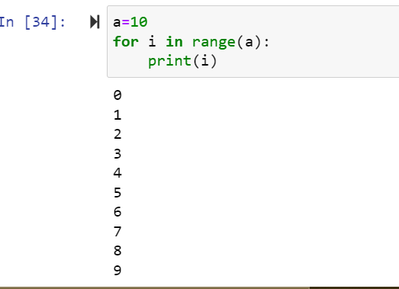

Using while loop.

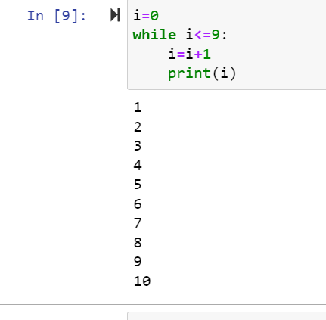

13. If you had a function named bacon() inside a module named spam, how would you call it after
importing spam?

Ans: This function can be called spam.bacon().

